MANAGEMENT INFORMATION SYSTEM

LAB EXPERIMENT:7

7) **Draw a UML diagram for online purchasing system. Provide top level use cases for a  web customer making purchases online. Web customer actor uses some web site to  make purchases online. Top level use cases are View Items, Make Purchase and Client  Register.**

**Aim:**

To develop a **Use Case Diagram** for an **Online Purchasing System**, illustrating the top-level interactions between web customers and the system.

**Procedure:**

**Step 1**: Identify the Actors

Actors represent external entities interacting with the system. In this case, we have:

Web Customer – A user who interacts with the system to browse, register, and make purchases.

System (Online Purchasing System) – The platform that handles the purchasing process.

**Step 2**: Identify the Top-Level Use Cases

Use Cases represent functionalities that the system provides. The top-level use cases for a Web Customer are:

View Items – Allows the customer to browse products available for purchase.

Make Purchase – The customer selects items and completes a purchase.

Client Register – A new customer registers on the website.

**Step 3**: Define the Relationships Between Actors and Use Cases

Web Customer → (View Items) → System

Web Customer → (Make Purchase) → System

Web Customer → (Client Register) → System

Additional Use Cases (Optional for Detail):

Add to Cart (extends "Make Purchase")

Provide Payment Details (included in "Make Purchase")

Receive Order Confirmation (extends "Make Purchase")

**Step 4:** Draw the Use Case Diagram

Using UML Tools like Lucidchart, Draw.io, or StarUML:

Draw a stick figure for the Web Customer.

Draw an oval for each use case (View Items, Make Purchase, Client Register).

Connect the Web Customer to relevant use cases using straight lines.

Enclose the use cases within a system boundary box labeled "Online Purchasing System."

**Step 5**: Review and Validate the Diagram

Ensure all essential functionalities are represented.

Verify relationships between actors and use cases are correct.

Use "include" and "extend" relationships if needed for better clarity.

Would you like me to generate an ASCII representation or provide a description for a UML tool?

**Output:**

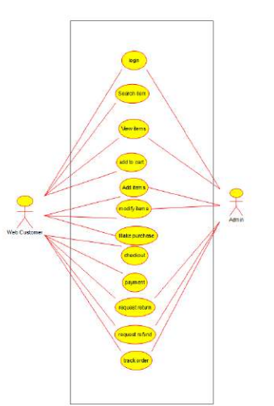

**Use case diagram**

**Result:**

A **UML Use Case Diagram** will be created based on the above analysis.